**Aim :-** Data Analysis using Time Series Analysis.

Time series is a series of data points in which each data point is associated with a timestamp.

A simple example is the price of a stock in the stock market at different points of time on a

given day. Another example is the amount of rainfall in a region at different months of the

year. R language uses many functions to create, manipulate and plot the time series data.

The data for the time series is stored in an R object called time-series object. It is also a R

data object like a vector or data frame.

The time series object is created by using the **ts()** function.

**Syntax**

The basic syntax for **ts()** function in time series analysis is –

timeseries.object.name <- ts(data, start, end, frequency)

Following is the description of the parameters used –

**• data** is a vector or matrix containing the values used in the time series.

**• start** specifies the start time for the first observation in time series.

**• end** specifies the end time for the last observation in time series.

**• frequency** specifies the number of observations per unit time.

Except the parameter "data" all other parameters are optional.

**Timeseries.R :-**

# Get the data points in form of a R vector.

rainfall <-

c(799,1174.8,865.1,1334.6,635.4,918.5,685.5,998.6,784.2,985,882.8,1071)

# Convert it to a time series object.

rainfall.timeseries <- ts(rainfall,start = c(2012,1),frequency = 12)

# Print the timeseries data.

print(rainfall.timeseries)

# Give the chart file a name.

png(file = "rainfall.png")

# Plot a graph of the time series.

plot(rainfall.timeseries)

# Save the file.

dev.off()

**Output :-**

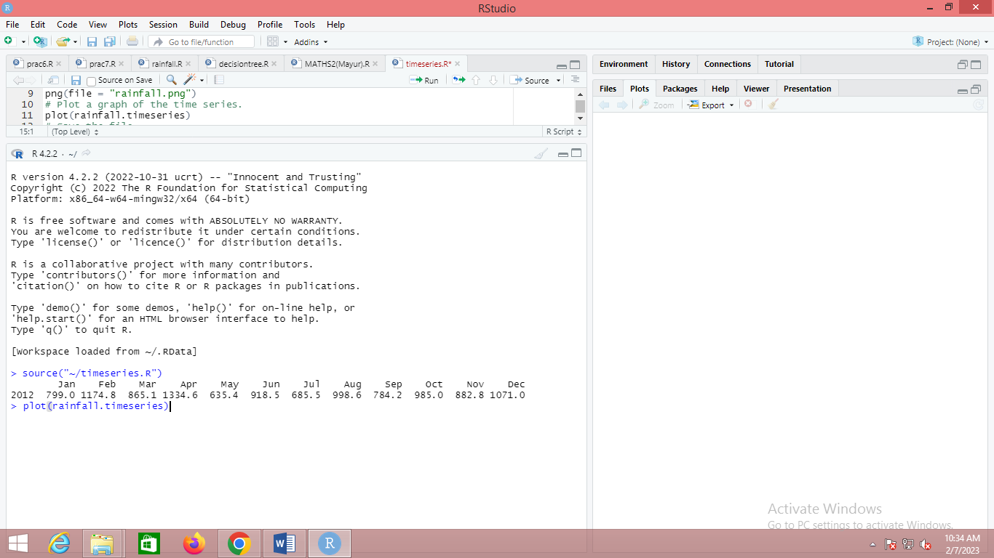

**Graph :-**

